Integrating Sequence, Structure, and Expression Features to Improve RNA Stability Prediction
B528 Computational Analysis of High-throughput Biomedical Data
Adam Wait

0. Abstract
RNA stability is a key factor in gene regulation, influencing transcript abundance as well as cellular functions. Despite its importance, the process of accurately predicting RNA stability remains a challenging problem. In this project, I evaluate whether integrating sequence, structure and expression features improve RNA stability prediction. Using transcript level data derived from genome-wide RNA decay measurements, I trained both regression and classification models to predict RNA half-life and stability categories. Regression models showed limited predictive performance, with only modest improvement over the baseline model, as R² increased from 0.143 to 0.169 in the best-performing model. Classification models achieved a moderate accuracy of 0.583 but exhibited a strong bias towards the majority class. While combining features and using nonlinear models provided slight improvements, overall predictive performance remained low. These results suggest that the simple feature representations were only able to capture general trends but are unable to fully explain RNA stability. Overall, this work establishes a baseline framework and highlights the need for more biologically informative features and more advanced modeling approaches.

Introduction
RNA stability plays a fundamental role in gene regulation by controlling how long transcripts remain available for translation. Variation in RNA half-life plays an important role in regulating cellular processes, enabling rapid responses to environmental and developmental signals. Genome-wide studies have demonstrated that RNA stability varies widely across transcripts [1,4], with some RNAs degrading rapidly while others remain stable for extended periods [1]. Notably, short-lived transcripts are often associated with regulatory functions, whereas long-lived transcripts are more commonly linked to housekeeping processes [1].
The mechanisms underlying RNA stability are complex and involve interactions between elements, structural features, and cellular factors. Sequence characteristics such as nucleotide composition and transcript length have been associated with stability, while RNA secondary structure can influence the availability of degradation mechanisms. RNA-binding proteins and other regulatory factors also play critical roles in determining transcript lifetimes [2]. However, these factors do not act independently, making it difficult to predict RNA stability from just a single feature type.
Computational approaches have attempted to model RNA stability using individual feature classes, but these methods often fail to capture the full complexity of RNA decay. Structural prediction methods, for example, typically rely on simplified representations such as minimum free energy, which may not reflect the dynamic nature of RNA folding [3]. As a result, predicting RNA stability remains a challenging problem in computational biology.
Recent advances in machine learning provide an opportunity to integrate multiple feature types and model complex biological relationships. By combining sequence, structure, and expression features, it may be possible to better capture the factors influencing RNA stability. However, the extent to which these features improve predictive performance, particularly within a simplified and interpretable framework, is not well established.
In this study, I evaluate the contribution of sequence, structure, and expression features to RNA stability prediction using both regression and classification approaches. By comparing different feature sets within a consistent modeling framework, I aim to determine whether integrating these features improves predictive performance and to establish a baseline for future work.

Methods

Dataset and Feature Preparation
RNA stability data were obtained from genome-wide measurements of transcript half-lives [1]. Each transcript was associated with a set of features representing expression, sequence, and structural properties. Expression values were log-transformed using log(1+x) to reduce skewness. RNA half-life values were similarly log transformed prior to regression modeling.
Sequence-based features were derived directly from transcript sequences. Transcript length was defined as the number of nucleotides in each RNA sequence. GC content was calculated as the proportion of guanine(G) and cytosine(C) nucleotides relative to total sequence length. Transcript type was included as a categorical variable representing different classes of RNA transcripts (e.g., coding and noncoding), as provided in the data set. Structural features were derived from predicted RNA secondary structures using the ViennaRNA package RNAfold. For each transcript, RNAfold was used to compute the minimum free energy (MFE), which represents the most thermodynamically stable predicted structure. MFE values were normalized by sequence length to obtain a per-nucleotide measure (MFE per nt), allowing comparison across transcripts of different lengths.

2.2 RNA Stability Classification
In addition to predicting continuous half-life values, transcripts were grouped into discrete stability categories to evaluate classification performance. Transcripts were divided into categories based on half-life:

- Short-lived: <2 hours
- Moderate: 2-4 hours
- Stable: 4-8 hours
- Long-lived: >8 hours

These categories were chosen to reflect biologically meaningful differences in RNA stability while maintaining balanced group sizes.

2.3 Model Development
Two modeling approaches were used to evaluate RNA Stability Prediction:

2.3.1 Regression Models
Linear regression models were trained using different features sets:
- Baseline Model: Expression and transcript length
- Sequence Model: Baseline features plus GC content and transcript type
- Structure Model: Structural features only
- Combined Model: All available features
In addition, a random forest regression model was trained using the full feature set to capture potential nonlinear relationships.

2.3.2 Classification Models
Random forest classifiers were used to predict RNA stability categories. Separate models were trained using the same feature sets as the regression models (baseline, sequence, structure, and combined).
Random forests were selected due to their ability to model nonlinear relationships and interaction between biological features without extensive parameter tuning.

2.4 Model Evaluation
The dataset was randomly split into training (80%) and testing (20%) sets. Model performance was evaluated on the held-out test set to assess generalization to unseen data.
Regression performance was measured using the coefficient of determination (R²). Classification performance was evaluated using overall accuracy and confusion matrix analysis to assess class-specific prediction behavior.

Results

Regression Performance
Regression models showed limited predictive performance across all feature sets. The baseline model achieved an R² of 0.143 while the sequence model showed a small improvement to 0.147. The structure-only model performed poorly, with an R² of 0.014, indicating that structural features alone provide little predictive value. The combined linear model achieved an R² of 0.150, representing only a modest improvement over the baseline.

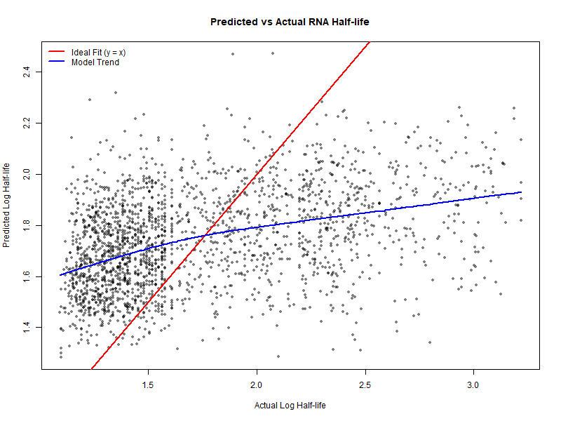  Figure 1. Predicted versus actual log-transformed RNA half-life values for the combined regression model. The red line represents the ideal fit (y = x), while the blue line shows the smoothed trend of model predictions. The wide scatter and deviation from the ideal indicate limited predictive performance, with predicted values concentrated within a narrow range. | Model Regression (R²) Classification Accuracy  Baseline 0.143 0.547  Sequence 0.147 0.566  Structure 0.014 0.483  Combined 0.150 0.583  Random Forest 0.169 —  Table 1. Model performance across regression and classification tasks. Classification models were implemented using random forests for all feature sets.

The predicted versus actual half-life plot (Figure 1) shows substantial scatter and deviation from the identity line. Predicted values are concentrated within a narrow range and fail to reflect the full variability of observed RNA half-life values, indicating limited model resolution.

Classification Performance
Classification Models achieved moderate accuracy across feature sets. The Baseline model achieved an accuracy of 0.547, while the sequence model improved slightly to 0.566. The structure-only model performed the worst, with an accuracy of .483. The combined achieved the highest accuracy at 0.583
As shown in Table 1, integrating sequence, structure, and expression features provides some improvement, although overall classification performance remains limited.

Confusion Matrix Analysis
Analysis of the confusion matrix (Figure 2) reveals a strong bias toward predicting the moderate stability class. A large proportion of transcripts were classified as moderate regardless of their true class.

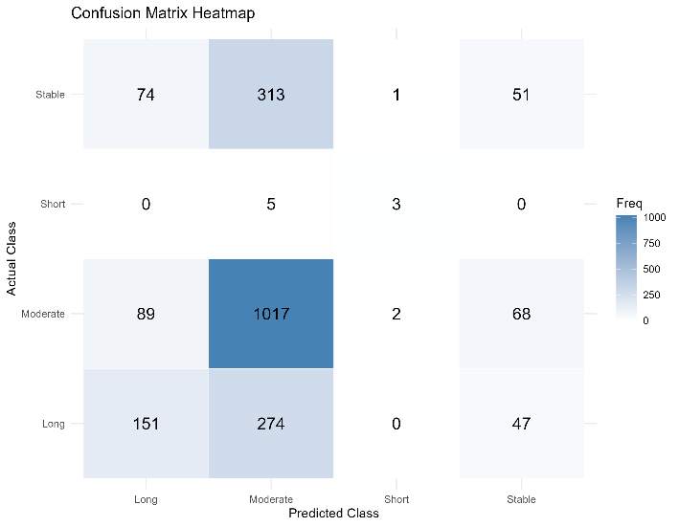  Figure 2. Confusion matrix heatmap for RNA stability classification using the combined random forest model. Rows represent actual stability classes, and columns represent predicted classes. The model shows a strong bias toward predicting the moderate class, with frequent misclassification of stable and long-lived transcripts. | 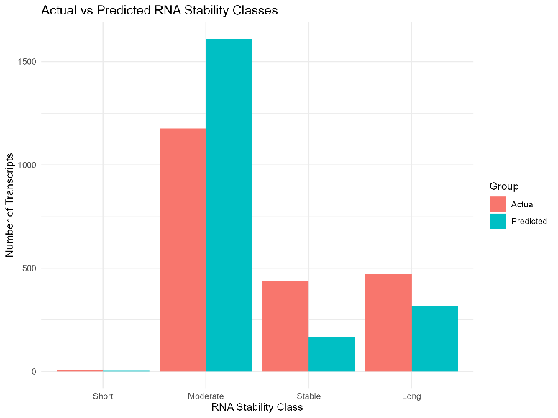Figure 3. Comparison of actual and predicted RNA stability class distributions. The predicted distribution is heavily skewed toward the moderate class, while the true distribution is more balanced across categories, indicating model bias and limited ability to distinguish between stability classes.
Stable and long-lived transcripts were frequently misclassified as moderate, while short-lived transcripts were rarely correctly identified. This indicates that the model struggles to distinguish between stability categories, particularly for minority classes.

Distribution of Predicted Classes
Comparison of actual and predicted RNA stability class distributions (Figure 3) reveals a clear imbalance in model predictions. While the true distribution of transcripts is relatively spread across stability categories, the predicted distribution is heavily skewed towards the moderate class.
The model substantially overpredicts the moderate category, while underpredicting the stable and long-lived transcripts. Short-lived transcripts are particularly underrepresented in the dataset, with only a small number of examples available. This limited representation likely restricts the model’s ability to learn distinguishing features for this class, contributing to poor classification performance despite some correct predictions
This pattern is consistent with the confusion matrix (Figure 2) and indicates that the model struggles to distinguish between stability classes. The overlap in feature distributions across categories and potential class imbalance likely contribute to this bias, limiting overall classification performance.

4.0 Discussion and Conclusion
This study evaluated whether integrating sequence, structure, and expression features improves RNA stability prediction. Overall, both regression and classification models showed limited predictive performance, indicating that RNA stability is a complex property that is not easily captured using simple feature representations.
Regression models demonstrated weak performance across all feature sets, with only modest improvement over the baseline model. Even the best-performing model, random forest regression, achieved and R² of 0.169, suggesting that only a small proportion of the variability in RNA half-life is explained by the features used in this study. Figure 1 further supports this, showing that predictions are concentrated within a narrow range and fail to capture the full variability of observed values.
Classification models performed slightly better, achieving moderate accuracy, with the combined model reaching 0.583. However, Figure 2 and Figure 3 revealed a strong bias towards predicting the moderate stability class. This suggests that the model is capturing general trends but lacks the ability to distinguish between more specific stability categories.
Several factors likely contribute to the limited performance observed. First, the structural features used in this study were based on minimum free energy predictions, which represent only a single static RNA conformation. RNA structure is highly dynamic and influenced by cellular context, which means that these simplified representations may fail to capture biologically relevant structural variation [3]. This likely explains the poor performance of the structure-only model.
Second, sequence features were limited to basic metrics such as GC content and transcript length. While these features can provide some information, they do not capture more complex regulatory elements such as sequence motifs or binding sites for RNA-binding proteins which are known to influence RNA stability [2]. As a result, the predictive power of sequence-based models remains limited.
Third, class imbalance within the dataset contributed to reduced classification performance. Short-lived transcripts were underrepresented, with only a small number of examples available. This limited representation likely restricted the model’s ability to learn distinguishing features for this class, resulting in poor classification despite some correct predictions.
Importantly, this study was intentionally designed to use relatively simple and interpretable features within the scope of a class project. While more complex models and features could improve performance, the goal was to establish a baseline framework and evaluate the contribution of different feature types. In this context, the results demonstrate that while integrating features provide some improvement, it is insufficient to fully capture the complexity of RNA stability.
Future work could improve RNA stability prediction by incorporating more biologically relevant features such as RNA-binding protein interactions, experimentally derived structural data, and sequence motif information. Additionally, more advanced modeling approaches, including deep learning methods, may better capture nonlinear relationships and complex interactions between features. Addressing class imbalance through data augmentation or alternative modeling strategies may also improve classification performance.
Overall, RNA stability prediction remains challenging, with limited improvement from combining simple features highlighting the complexity of the underlying biological processes. More informative biological and advanced modeling approaches will be required in the future to achieve meaningful predictive performance.

References
[1] Tani, H., Mizutani, N., Ijiri, H., Wakamatsu, Y., Kurokawa, R., Yamada, K., Shiraki, T., Carninci, P., Hayashizaki, Y., & Suzuki, T. (2012).
Genome-wide determination of RNA stability reveals hundreds of short-lived noncoding transcripts in mammals. Genome Research, 22(5), 947–956.
[2] Garneau, N. L., Wilusz, J., & Wilusz, C. J. (2007).
The highways and byways of mRNA decay. Nature Reviews Molecular Cell Biology, 8(2), 113–126.
[3] Chaturvedi, A., et al. (2025).
RNA structure prediction using deep learning: A comprehensive review. Computers in Biology and Medicine.
[4] Sharova, L. V., Sharov, A. A., Nedorezov, T., Piao, Y., Shaik, N., & Ko, M. S. H. (2009).
Database for mRNA half-life of mouse genes. DNA Research, 16(1), 45–58.

